Practicum Case | 
ISYS6123
Introduction to Database Systems
Information Systems | O221-ISYS6123-DD01-08
Valid on Odd Semester Year 2021/2022 | Revision 00

Learning Outcomes
- Query of SQL that suitable with the problem

Topic
- SQL – Data Manipulation (Sub Queries)

Subtopics
- Subqueries (IN, EXISTS, ALL, SOME, ANY)
- Alias Subquery

Tabel Relasional
Relational Table

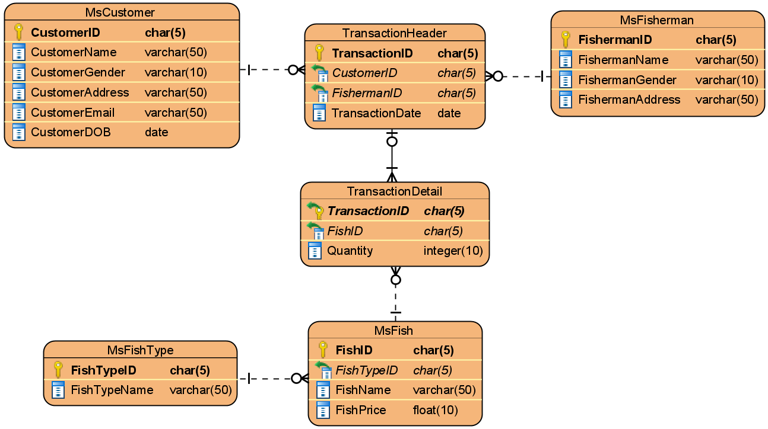

Soal
Case

- Display FishermanID and FishermanName for every fisherman whose ID is ‘FS001’, ‘FS003’, or ‘FS011’.
(in)
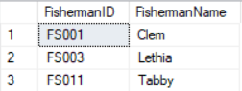

- Display FishName and FishPrice for every fish which type is not ‘Marlin’, ‘Grouper’, or ‘Bass’.
(in, not in)
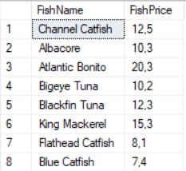

- Display CustomerName and CustomerEmail for every male customer who never did any transaction.
(not in)
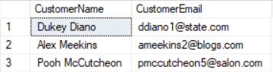

- Display FishTypeName, FishName, and FishPrice for every fish that was bought by a female customer and the transaction occured on the 2nd Quarter of 2020.
(in, datename, quarter, year)
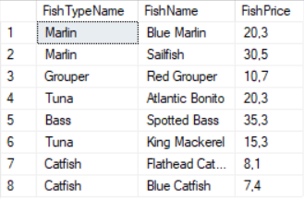

- Display CustomerName and Transaction Date (obtained from TransactionDate in ‘dd mon yyyy’ format) for every transaction in which the fish price is above 35.
(convert, exists)
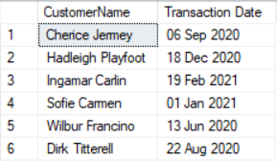

- Display CustomerName, CustomerGender, and CustomerEmail for every customer who bought fish from a female fisherman and her name starts with ‘L’ or ‘R’.
(exists, left, in)
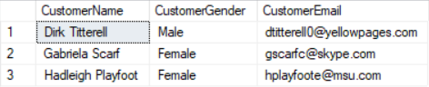

- Display CustomerID and CustomerName for every male customer and never bought any fish which type is Tuna.
(in, not exists)
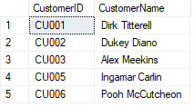

- Display FishName, FishTypeName, and FishPrice for every fish which price is higher than the average of all fish's price.
(alias subquery, avg)
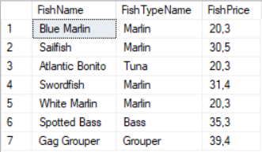

- Display FishName and FishPrice for every fish with highest price or the lowest price.
(alias subquery, max, min, in)
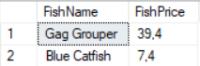

- Display CustomerName, CustomerEmail, and Fish Type Variant (obtained from the total number of fish type) for every transaction which has the lowest total number of fish type.
(alias subquery, min, count)
